OES Question Bank — Bulk Import Template (Word)

INSTRUCTIONS:
1. Fill in the table below. The first row (blue header) will be skipped during import.
2. Column order is fixed — do not add, remove, or reorder columns.
3. Correct Answer must be exactly: A, B, C, or D.
4. Difficulty must be one of: A, B, C, D, or E (maps to Level A–E).
5. For non-MCQ questions (e.g., 5_mark), leave Options A–D blank.
6. Nested tables inside cells are now supported (Recommended for complex data).
7. Subject must match a name already configured in the system.
8. For Math/Chemistry formulas, use LaTeX format (e.g., $E=mc^2$) for best results.

COLUMN REFERENCE:
Col 1: Std | Col 2: Group | Col 3: Type | Col 4: Diff | Col 5: Sub | Col 6: Chp | Col 7: Topic | Col 8: Body
Col 9-12: Opt A-D | Col 13: Correct Ans | Col 14: Solution | Col 15: Video | Col 16: Image

Standard | Group | Question Type | Difficulty Level | Subject | Chapter | Topic | Question Text | Option A | Option B | Option C | Option D | Correct Answer | Solution Text | Solution Video Link | Solution Image
11th English | A Group (Board) | MCQ | Level A | PHYSICS | Chapter 1 | General Topic | A circular hole of radius $\frac{a}{2}$ is cut out of a circular disc of radius ‘a’ as shown in figure. The centroid of the remaining circular portion with respect to point ‘O’ will be  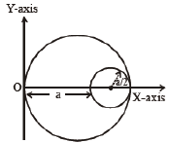 | $$\frac{1}{6}a$$ | $$\frac{10}{11}a$$ | $$\frac{5}{6}a$$ | $$\frac{2}{3}a$$ | C | Explanation/Solution for this MCQ question. |  | 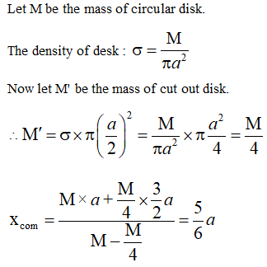
11th English | A Group (Board) | MCQ | Level A | PHYSICS | Chapter 1 | General Topic | Two identical metal wires of thermal conductivities K1 and K2 respectively are connected in series. The effective thermal conductivity of the combination is | $$\frac{2K_{1}K_{2}}{K_{1}+K_{2}}$$ | $$\frac{K_{1}+K_{2}}{2K_{1}K_{2}}$$ | $$\frac{K_{1}+K_{2}}{K_{1}K_{2}}$$ | $$\frac{K_{1}K_{2}}{K_{1}+K_{2}}$$ | A | Explanation/Solution for this MCQ question. |  | 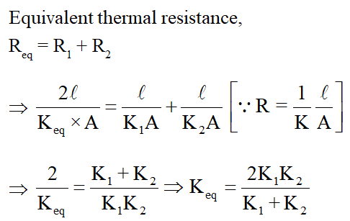
11th English | A Group (Board) | MCQ | Level A | PHYSICS | Chapter 1 | General Topic | A light ray does not bend at the boundary in passing from one medium to the other medium if the angle of incidence is : | $$0^{∘}$$ | $$45^{∘}45^{∘}$$ | $$60^{∘}60^{∘}$$ | $$90^{∘}90^{∘}$$ | C |  |  | 
11th English | A Group (Board) | MCQ | Level A | PHYSICS | Chapter 1 | General Topic | If P = $\left[\begin{matrix}1 & 0 \\ 1/2 & 1\end{matrix}\right]$,then P50 is | $$\left[\begin{matrix}1 & 0 \\ 25 & 1\end{matrix}\right]$$ | $$\left[\begin{matrix}1 & 50 \\ 0 & 1\end{matrix}\right]$$ | $$\left[\begin{matrix}1 & 25 \\ 0 & 1\end{matrix}\right]$$ | $$\left[\begin{matrix}1 & 0 \\ 50 & 1\end{matrix}\right]$$ | D |  |  | 
11th English | A Group (Board) | MCQ | Level A | PHYSICS | Chapter 1 | General Topic | A student learns that magnetic field strength around a bar magnet is different at every point. Which diagram shows the correct magnetic field lines around a bar magnet ? | 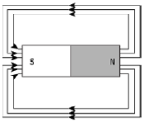 | 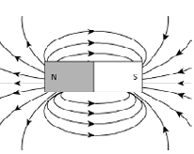 | 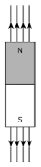 | 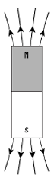 | A |  |  | 
11th English | A Group (Board) | MCQ | Level A | PHYSICS | Chapter 1 | General Topic | For a concave lens, when the object is at a distance equal to the focal length of the lens, the image is formed at : | optical centre | second focus | first focus | mid point between the optical centre and second focus of the lens | D |  |  | 
11th English | A Group (Board) | MCQ | Level A | PHYSICS | Chapter 1 | General Topic | The refractive index of turpentine is higher than that of water, while its mass density is lower than water. The figure given below shows a layer of turpentine floating over water taken in a container. For which one of the four rays incident on turpentine in the path shown in the figure is correct ?  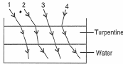 | Ray 1 | Ray 2 | Ray 3 | Ray 4 | B | Explanation/Solution for this MCQ question. |  | 

